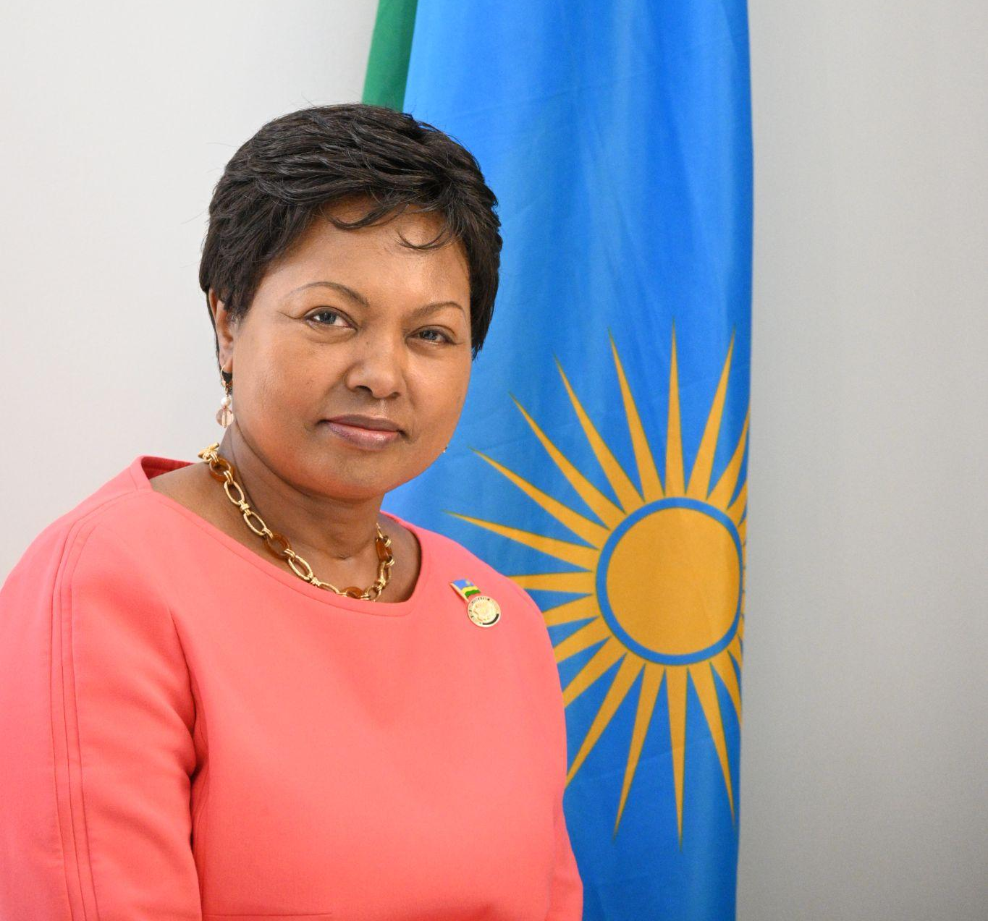
H.E. Ambassador Mathilde Mukantabana biography
Professor Mathilde Mukantabana serves as Ambassador Extraordinary and Plenipotentiary of the Republic of Rwanda to the United States of America, as well as non-resident Ambassador to Mexico and Argentina. Her ambassadorial responsibilities include promoting stronger bilateral relations with the US, Argentina, and Mexico, advancing Rwandan policies and priorities abroad, championing Rwanda’s culture, history, and economy, and engaging Rwanda’s diaspora in the United States to participate in the development of their country of origin. Her regular work entails frequent interactions with elected and appointed officials in all branches of government as well as with multilateral bodies, civil society organizations, and all major civic and educational institutions.

Prior to her diplomatic career, Ambassador Mukantabana served in higher education as a tenured professor of History in Sacramento, California, and as a lecturer of Social Work at the National University of Rwanda. Concurrent with her academic work, she co-founded Friends of Rwanda Association (F.O.R.A), a nonprofit American relief organization launched in the wake of the 1994 Genocide against Tutsi in Rwanda. In addition, under the aegis of the United Nations for Development Programs (UNDP), Ambassador Mukantabana started the academic program of Social Work at the National University of Rwanda in 1999 and was a Lecturer in the program for several years. She also serves on the Sonoma State University board of Holocaust and Genocide Studies

Ambassador Mukantabana is a much sought-after national and international speaker and has presented to diverse audiences including major universities, global forums, international organizations, congressional and parliamentary hearings, think tanks, and international film and arts festivals. She has extensive experience in organizing and leading international conferences focusing on Genocide, conflict, and peace resolution.

Ambassador Mukantabana has won many awards attesting to her accomplishments including Peace and Justice Award from the Center for African Peace and Conflict Resolution (CAPCR); Peace and Global Peace Award (on behalf of Friends of Rwanda Association) by Global Majority, Crystal Apple Award for Best Instructor at Cosumnes River. In addition, she is a recipient of several “Key to the City” awards in several US cities and was inducted into the 5000 Role Models of Excellence at the margins of the 27th celebration of Martin Luther King Jr. birthday.

She is the 2023 recipient of the Honorary Doctoral Degree of Humane Letters (L.H.D) at California State University Sacramento.

Fluent in English, French, Kinyarwanda, and Kirundi, Ambassador Mukantabana holds a Bachelor’s degree in History and Geography from the University of Burundi, a Master’s of Arts in History and a Master’s degree in Social Work both from California State University in Sacramento, California.

